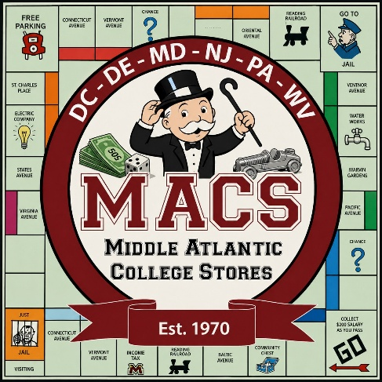

Preliminary Show Schedule
October 5 & 6, 2026
Doubletree Reading, PA
Monday, October 5, 2026

8:00 – 5:00 pm Registration

8:00 – 9:00 am Breakfast

9:00 – 9:50 am Welcome and Opening Session
Driving GM Sales at High Speeds – Kevin Leitner, ICBA
You’ve built a great assortment of the right products from top vendors at the right prices in the right categories, but none of that matters if you don’t step on the gas and drive sales! This session will discuss practical ways to grow sales without just resorting to steep discounting. We’ll explore taking advantage of both recurring and non-recurring events to maximize opportunities that are unique to your campus. We’ll also address how to increase sales to departments and even ways to make markdowns work for you. There will even be time for you to share your best “Ferrari-worthy” sales drivers.

10:00 – 10:50 am Concurrent Break Out Sessions
- Staying Ahead: Helping Your Campus Stay Compliant – John Creed, VitalSource
Independent campus stores are uniquely positioned to be more than a point of sale; they're trusted partners in the academic experience. With ADA Title II Digital Accessibility requirements set to take effect April 24, 2027, institutions face real legal exposure: failure to ensure digital course materials meet WCAG 2.1 AA standards can result in fines, legal action, and even loss of federal funding. Institutions are solely responsible for the accessibility of the digital content and tools they select including textbooks, websites, mobile apps, and other learning materials. That responsibility makes course material decisions more consequential than ever, and it creates a meaningful opportunity for campus stores to show up as informed, solutions-oriented partners. In this session, VitalSource breaks down what the new rule means in practice and how stores can help their campuses navigate it confidently.

- Data Driven Conversations – Lacey Wallace, NACS
Want to get more meaningful, actionable feedback from your customers? This hands-on workshop covers the essentials of running effective focus
groups. Learn when to use them, how to recruit the right participants, and how to craft questions that spark honest, useful conversations. Along the way, pick up techniques for handling tricky moments and keeping discussions on track. Build confidence in your approach and leave with a clear playbook you can put into practice right away.

11:00 – 11:50 am Concurrent Break Out Session
- Sustainability Session - TBD

- Beyond the Logo: Building a Cohesive Brand Identity for Your Campus Store. – Megan Wallis, CMU
Your campus store is more than a place to shop; it's an extension of your university's brand. Learn how to create a consistent identity that connects your physical store, website, email marketing, social media, signage into one seamless experience.

12:00 – 1:00 pm Lunch
Networking: Get to know your colleagues and their campus!

1:00 – 1:50 pm General Session – Retailing Finance 101 – Kevin Leitner, ICBA
What are the key metrics that you need to know in a college store business environment? In this practical session, designed for all types of staffing roles, not just accountants, we will explore basic financial terms and concepts for a retail business and how everyday activities of your team impact real-world results. What impact does improving inventory turns have on the bottom line? What is the difference between initial margin and maintained margin and why does it matter? Learn to read a basic income statement and learn its key factors to influence results.

2:00 – 2:50 pm Concurrent Break Out Sessions
- From Access to Impact – John Creed, VitalSource
Your store has been doing the hard work. You've driven down course material costs, launched digital first programs, and helped students get day one access to the materials they need. But here's the uncomfortable question: are students actually using them? This session will introduce a new way to evaluate the health of your digital program that measures not just what students pay, but what they actually get for it. We'll show you what this looks like across real campus programs, how to identify adoptions that are underperforming on engagement, and what practical options exist to address them.

- Practical Uses of AI for College Store – Kevin Leitner, ICBA
AI tools are empowering people and businesses in ways that are evolving rapidly every day. There are already many success stories in our industry demonstrating how college stores are using AI to make faster, better, and more accurate business decisions. This session will review the top ways college stores are using AI in general, and then we’ll share a series of specific real-life examples of how AI is being successfully used by college stores of all types and sizes. This session will also include an opportunity for attendees to share their own experiences and tips for using AI so we can all learn from one another.

2:50 – 3:10 pm Afternoon Break

3:10 – 3:50 pm Roundtable Discussions
- Social Media
- Course Materials
- General Merchandise

4:00 – 4:30 pm Vendor Presentations
Get a sneak peek at what vendors will be showing during trade show.

4:30 – 5:15 pm MACS Business Meeting

5:30 – 6:30 pm Break

6:30 – 7:00 pm Happy Hour w/ H’orderves
7:00 – 9:00 pm Opening Night Dinner/Party

Tuesday, October 6, 2026

7:00 – 10:45 am Registration

7:00 – 10:00 am Trade Show Setup for Vendors

8:00 – 9:00 Breakfast Buffet

8:45 – 9:30 am Vendor Presentations
Get a sneak peek at what vendors will be showing during trade show.

9:45 – 10:45 am Student Watch 2026: Trends & Highlights – Lacey Wallace, NACS
Discover what students really think about course materials in this data-packed session. Hear highlights from the OnCampus Research 2026 Student Watch
survey, including spending trends, buying behaviors, format preferences, and student views on cost, debt, and sustainability. Get the latest insights to better
understand today’s students!

11:00 – 12:00 pm Trade Show – Part 1

12:00 – 1:00 pm Lunch on Trade Show Floor (Store and Vendor Members)

1:00 – 3:00 pm Trade Show Wrap Up
3:00pm Vendor Breakdown

